**Franchise Management CRM Project**

Demo video Link: <https://drive.google.com/file/d/1QJZFBKv3GXsPnN4kl3cmw2dfajKinvZu/view?usp=sharing>

**Phase 1: Problem Understanding & Industry Analysis**

**Goal:** Understand what we are building for franchise management and why it is needed.

**1. Requirement Gathering**

* Engage with key stakeholders: franchisor, franchisees, sales managers, support staff.
* Example requirements:
  + Track all franchise locations and their operational status.
  + Facilitate franchisee onboarding, including document collection and approval.
  + Monitor sales, revenue, and performance across all locations.
  + Centralize customer data and manage franchisee-customer interactions.
  + Automate communications, reminders, and approvals for key processes.

**2. Stakeholder Analysis**

* Admin: Responsible for system setup and configuration.
* Franchisee: Manages own location’s data, uploads reports, receives updates and notifications.
* Franchisor/Manager: Oversees multiple franchisees, approves requests, monitors analytics and reports.
* Support Staff: Assists with onboarding, troubleshooting, and compliance issues.

**3. Business Process Mapping**

* Typical process flow:

1. Franchisee submits onboarding request.

2. Admin reviews submitted documents.

3. Manager approves or rejects onboarding.

4. Franchise location is activated.

5. Franchisee submits regular reports and feedback.

6. Manager reviews performance and provides feedback.

**4. Industry-specific Use Case Analysis**

* Franchise networks require standardized operations, compliance checks, and performance tracking.
* Specific needs:
  + Streamlined onboarding and document management.
  + Automated compliance and reporting reminders.
  + Real-time analytics of franchise performance.
  + Centralized communication channels.

**5. Market Exploration**

* Review existing Franchise Management solutions on platforms like Salesforce AppExchange.
* Decision to build a custom CRM for flexibility, tailored processes, and deeper learning.

**Phase 2: Org Setup & Configuration**

**Goal:** Prepare the Salesforce environment to support Franchise Management CRM processes.

**1. Salesforce Edition**

* Confirm you are using a Salesforce Developer Edition or an unrestricted org suitable for development and testing.

**2. Company Profile Setup**

* + Go to Setup > Company Settings > Company Information.
  + Enter company name (e.g., “MVGR Franchise Group”), address, and contact details.
  + Set the correct time zone for your organization’s operations.
  + Choose appropriate currency (e.g., INR or USD) based on your business region.

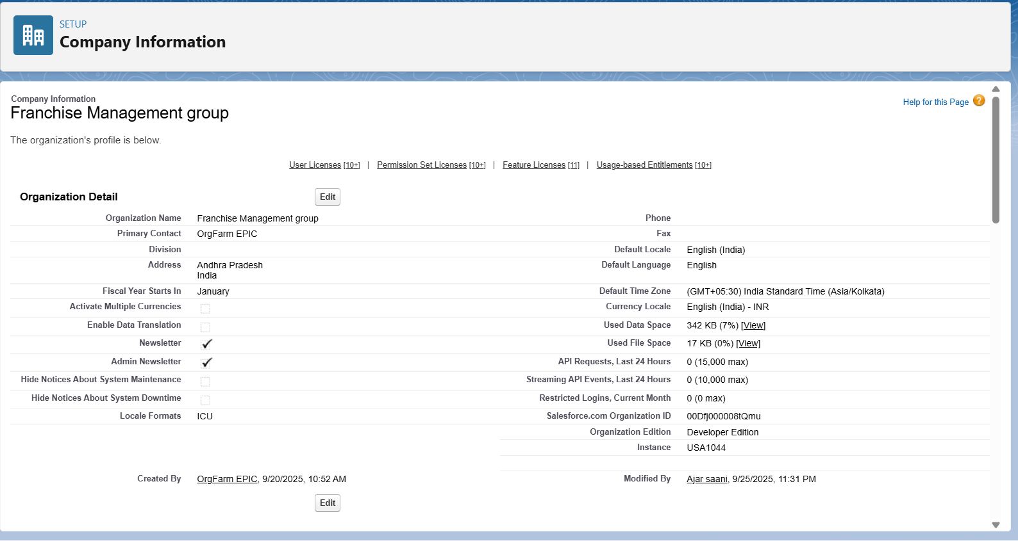

**3.** **Business Hours & Holidays**

* Navigate to Setup > Business Hours.
  + Define standard operating hours (e.g., Monday–Saturday, 9am–6pm).
* Add Public Holidays under Setup > Holidays.
  + Specify holidays where approvals or business operations are restricted.

**4. Fiscal Year Settings**

* Go to Setup > Fiscal Year.
* Set the fiscal year type (e.g., Standard: January–December) for consistent revenue reporting.

**5. User Setup & Licenses**

* Under Setup > Users, create the following user types:
* Franchisee
* Manager/Franchisor
* Support Staff/Admin
* Assign each user a Salesforce license (e.g., Standard User, System Administrator as needed).

**6. Profiles**

* Create or modify profiles for:
* Franchisee: Limited access—can view/edit own records, submit reports.
* Manager: Full access—can view/manage all franchisee records, approve requests.
* Support/Admin: Configuration and troubleshooting permissions.

**7. Roles**

* Define a role hierarchy:
* Manager (top-level, oversees all franchisees)
* Franchisee (reports up to Manager)
* Use Setup > Roles to set up visibility and reporting structure.

**8. Permission Sets**

* If a user needs extra permissions (e.g., access to reports or dashboards), create a Permission Set rather than modifying their profile.

**9. Org-Wide Defaults (OWD)**

* Go to Setup > Sharing Settings.
* Franchise Location Object: Public Read Only.
* Franchise Reports/Requests Object: Private (only owner and manager can view).

**10. Sharing Rules**

* Create sharing rules if you want franchisees to collaborate or share certain records.
* Example: Allow all franchisees in a region to see regional sales data.

**11. Login Access Policies**

* Under Setup > Login Hours, restrict login hours for franchisees (e.g., 9am–6pm).
* Use Login IP Ranges to restrict access to trusted networks.

**12. Developer Org Usage**

* Use this org as your sandbox for building and testing CRM features and automations.

**13. Sandbox & Deployment (for real companies)**

* In production scenarios, build in a Sandbox and deploy to Production using Change Sets.

**14. Deployment Basics**

* Use Change Sets or Salesforce Ant Migration Tool/SFDX for moving components, objects, and automations from development to production.

**Phase 3: Data Modeling & Relationships**

**Goal:** Establish a robust data structure in Salesforce to support franchise operations and reporting.

**1. Standard & Custom Objects**

* Standard Objects:
* Contact: For storing customer details and communication.
* Account: Can be used for franchise location records if preferred.
* Custom Objects:
* Franchisee: Represents each franchise location or owner.
* Franchise Report: Tracks franchise sales, compliance, issues, and feedback.

**2. Fields**

**1. Franchise Location**

* Represents each outlet/store in your franchise network.
* Key Fields:
  + Location Name (Text)
  + Address (Text Area)
  + Region (Picklist: North, South, East, West, etc.)
  + Franchisee Owner (Lookup → User)
  + Start Date (Date)
  + Status (Active/Inactive, Picklist)

**2. Sales Record**

* Tracks daily/weekly/monthly sales per outlet.
* Key Fields:
  + Franchise Location (Lookup → Franchise Location)
  + Date (Date)
  + Sales Amount (Currency)
  + Items Sold (Number)
  + Notes (Text Area)

**3. Compliance Check**

* Stores audit/compliance inspection results.
* Key Fields:
  + Franchise Location (Lookup → Franchise Location)
  + Audit Date (Date)
  + Auditor (Lookup → User)
  + Compliance Score (Number/Percent)
  + Issues Found (Text Area)
  + Status (Pass/Fail, Picklist)

**4. Franchisee Request / Support Ticket**

* Allows franchisees to raise requests to HQ (e.g., supplies, marketing help).
* Key Fields:
  + Request Type (Picklist: Supply, Marketing, IT Support, Other)
  + Franchise Location (Lookup)
  + Request Date (Date/Time)
  + Status (Open, In Progress, Closed)
  + Assigned To (Lookup → User)

**3. Record Types**

* Franchise Report:
* Monthly Report (regular sales and performance)
* Issue Report (problems or incidents)
* Compliance Report (regulatory and operational checks)

**4. Page Layouts**

* Franchisee Page:
* Shows franchise location details, status, contact info, and related reports.
* Franchise Report Page:
* Displays submission details, sales data, issues, related franchisee, and manager comments.
* Onboarding Request Page:
* Includes franchisee reference, submitted documents, status, and approval history.

**5. Compact Layouts**

* Configure mobile and list views showing essential fields:
* Franchisee: Name, Status, Location
* Report: Type, Submission Date, Status

**6. Schema Builder**

* Use Salesforce Schema Builder to visually design and verify relationships between objects:
* Franchisee ↔ Franchise Report: One-to-many via Lookup
* Franchisee ↔ Onboarding Request: One-to-many via Lookup
* Manager/Franchisor ↔ Franchise Report: Lookup, for approvals/comments

**7. Relationship Types**

* Lookup Relationship:
* Franchisee ↔ Reports (one franchisee, many reports)
* Franchisee ↔ Onboarding Requests (one franchisee, many requests)
* Master-Detail Relationship:
* Use if you need cascading deletes or roll-up summary fields (optional, based on requirements).
* Hierarchical Relationship:
* For manager/franchisee hierarchy, generally handled via roles rather than object relationships.

**8. Junction Objects**

* Needed only if a report can be linked to multiple franchisees (e.g., joint ventures).
* Not required for simple one-to-many relationships.

**9. External Objects**

* Use External Objects if integrating with outside databases (e.g., compliance, financial systems).

**Phase 4: Process Automation (Admin)**

**Goal:** Automate key franchise management processes in Salesforce to ensure efficiency, accuracy, and compliance.

**1. Validation Rules**

* Purpose: Ensure data integrity and enforce business logic.

Examples:

* Franchisee activation date cannot be in the future.
* Report submission must include required fields (e.g., sales data, feedback).
* Onboarding request documents must be uploaded before submission.

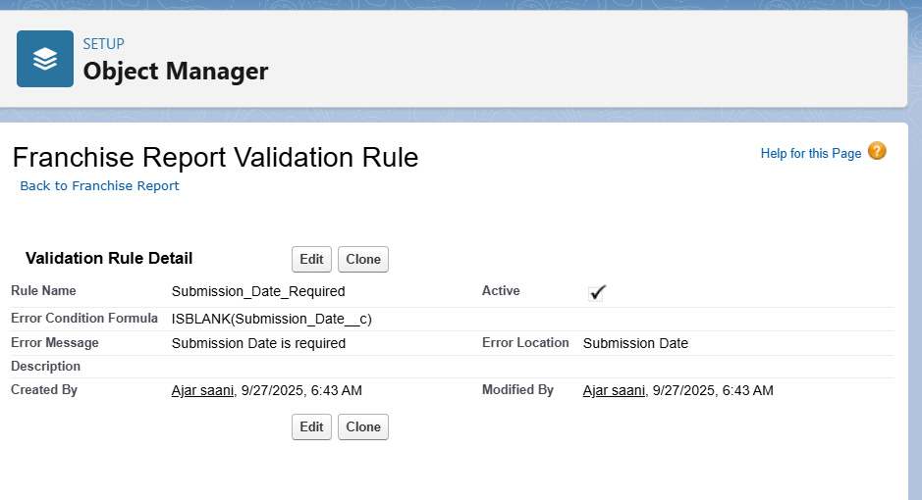

**2. Workflow Rules (Legacy)**

* Purpose: Automate routine tasks such as sending notifications or updating fields.

Examples:

* Automatically send an email to the manager when a new franchise report is submitted.
* Notify franchisees of overdue compliance reports.

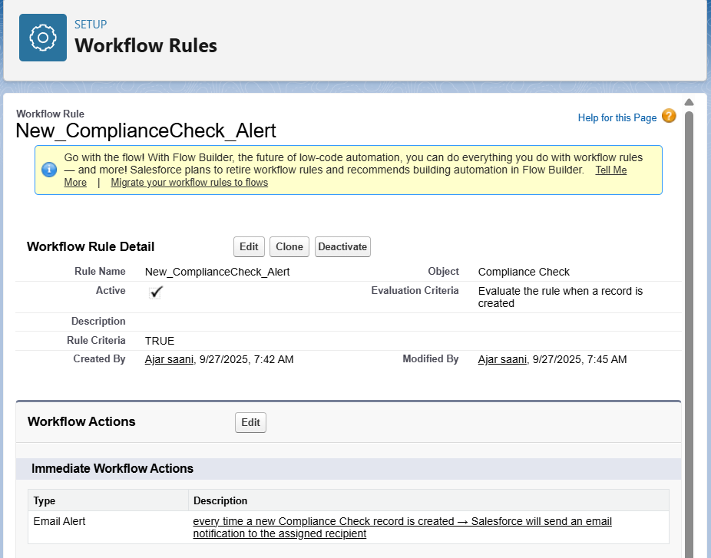

**3. Process Builder (Legacy)**

* Purpose: Automate more complex processes, such as updating related records or launching approval flows.

Examples:

* When a franchisee submits a report, update the franchisee status to "Reporting Active".
* When an onboarding request is approved, change franchisee status to "Active".

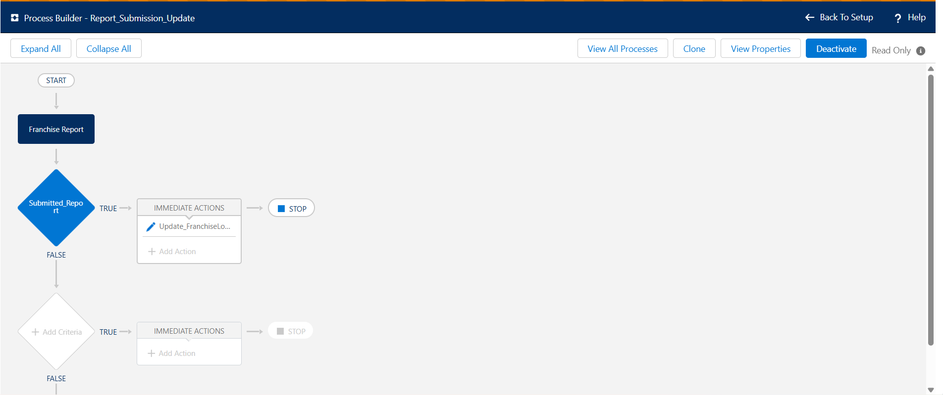

**4. Approval Process**

* Purpose: Ensure that critical actions require managerial review and sign-off.

Examples:

* Franchisee onboarding requests must be approved by the manager before activation.
* Reports indicating compliance issues must be approved before closure.

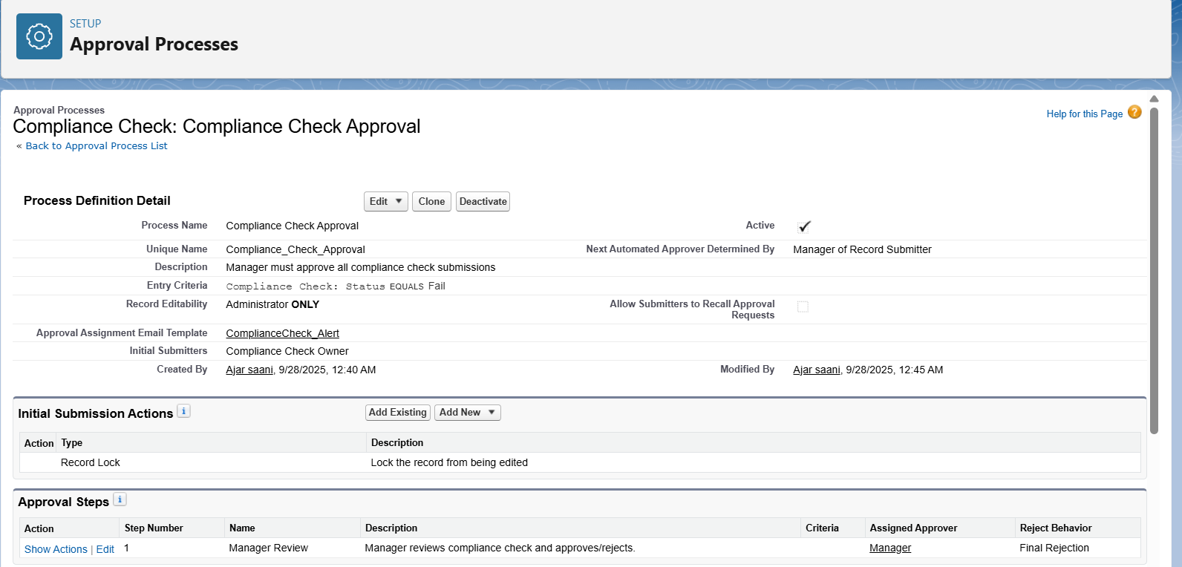

**5. Flow Builder (Recommended)**

* Purpose: Build flexible, scalable automations for record-triggered events, screen flows, and complex logic.

Examples:

* Record-Triggered Flow: When a report is submitted, automatically calculate performance metrics and update the franchisee record.
* Screen Flow: Guide user through franchisee onboarding steps, collecting necessary information and documents.

**6. Email Alerts**

* Purpose: Keep stakeholders informed of key events and approvals.

Examples:

* Send email confirmation to franchisee after onboarding approval.
* Email reminder to managers about upcoming compliance deadlines.

**7. Field Updates**

* Purpose: Automatically update record fields based on business logic or workflow outcomes.

Examples:

* Change franchisee status to “Active” after onboarding is approved.
* Update report status to “Reviewed” after manager approval.

**8. Tasks**

* Purpose: Assign follow-up actions to users based on workflow triggers.

Examples:

* Create task for support staff to review onboarding documentation.
* Assign periodic sales reporting tasks to franchisees.

**9. Custom Notifications**

* Purpose: Provide real-time, in-app alerts for important events (e.g., approvals, deadlines).

Examples:

* Notify franchisee when onboarding is approved.
* Alert manager of overdue compliance reports.

**Phase 5: Apex Programming (Developer)**

**Goal:** Implement custom business logic and automation beyond declarative tools using Apex, enabling complex processes, data manipulation, and asynchronous operations.

**1. Classes & Objects**

**Use Case:**

* Create Apex classes to handle reusable business logic, such as calculating franchisee performance scores, sending customized notifications, or aggregating sales data.
* Example: FranchiseePerformanceCalculator class computes monthly performance metrics for each franchise location.

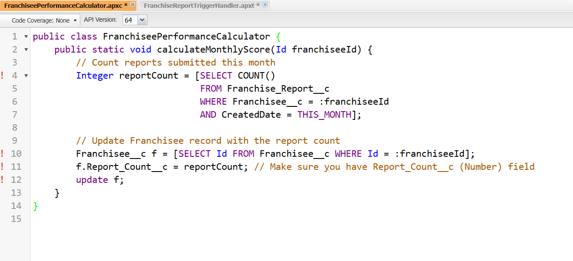

**2. Apex Triggers (before/after insert/update/delete)**

**Use Case:**

* Automate actions based on record changes.
* Example:
  + **Before Insert:** Validate data, e.g., ensure franchisee start date is not in the future.
  + **After Insert:** Automatically create a default onboarding checklist for new franchisees.

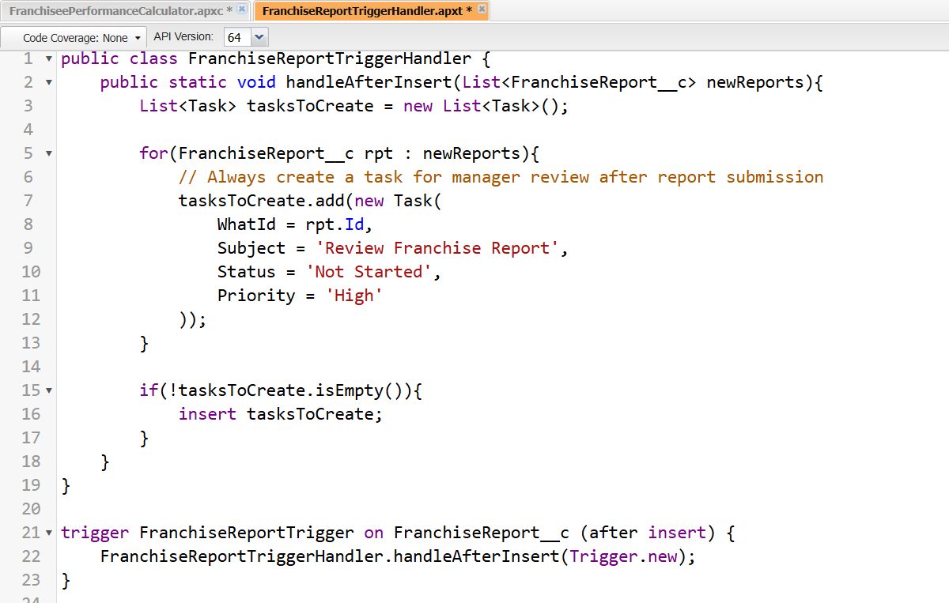

**3. Trigger Design Pattern**

**Use Case:**

* Implement best practices using Trigger Handler classes to separate logic from triggers.
* Example: FranchiseReportTriggerHandler handles all validations, field updates, and notifications when reports are created or updated.

**4. SOQL & SOSL**

**Use Case:**

* Query Salesforce data efficiently for reports, automation, or UI components.
* Example: Retrieve all active franchisees in a specific region for performance evaluation:

**5. Collections: List, Set, Map**

**Use Case:**

* Handle multiple records efficiently in Apex logic.
* Example: Use a Map to relate Franchisee IDs with their total sales for batch updates.

**6. Control Statements**

**Use Case:**

* Apply if-else, loops, and switch statements for logic execution.
* Example: Loop through all submitted reports and flag those with compliance issues for manager review.

**7. Batch Apex**

**Use Case:**

* Process large volumes of data asynchronously.
* Example: Calculate monthly sales summaries for all franchisees across regions without hitting governor limits.

**8. Queueable Apex**

**Use Case:**

* Execute complex or chained processes asynchronously.
* Example: Send weekly automated performance reports to managers after batch data processing.

**9. Scheduled Apex**

**Use Case:**

* Automate repetitive tasks at defined intervals.
* Example: Schedule nightly updates to calculate franchisee compliance scores.

**10. Future Methods**

**Use Case:**

* Perform operations asynchronously for long-running processes.
* Example: Update external systems with franchisee onboarding data after record creation.

**11. Exception Handling**

**Use Case:**

* Handle runtime errors gracefully and provide notifications or logs.
* Example: Catch failed SOQL queries in a batch process and log them to a custom error object.

**12. Test Classes**

**Use Case:**

* Ensure code coverage and validate functionality of Apex classes and triggers.
* Example: Test creation of onboarding requests, validation logic, and automated notifications.

**13. Asynchronous Processing**

**Use Case:**

* Combine Batch, Queueable, Scheduled Apex, and Future methods to handle data-heavy or time-intensive operations efficiently.
* Example: Automated monthly franchise performance calculation + notifications sent asynchronously to managers.

**Phase 6: User Interface Development**

**Goal:** Build a user-friendly interface in Salesforce for franchise management operations, enabling easy access to data, automation results, and key processes.

**1. Lightning App Builder**

**Use Case:**

* Create custom apps that group relevant objects, tabs, and components for franchise management.
* Example: “Franchise Management CRM” includes tabs for Franchisee, Reports, and Dashboards.

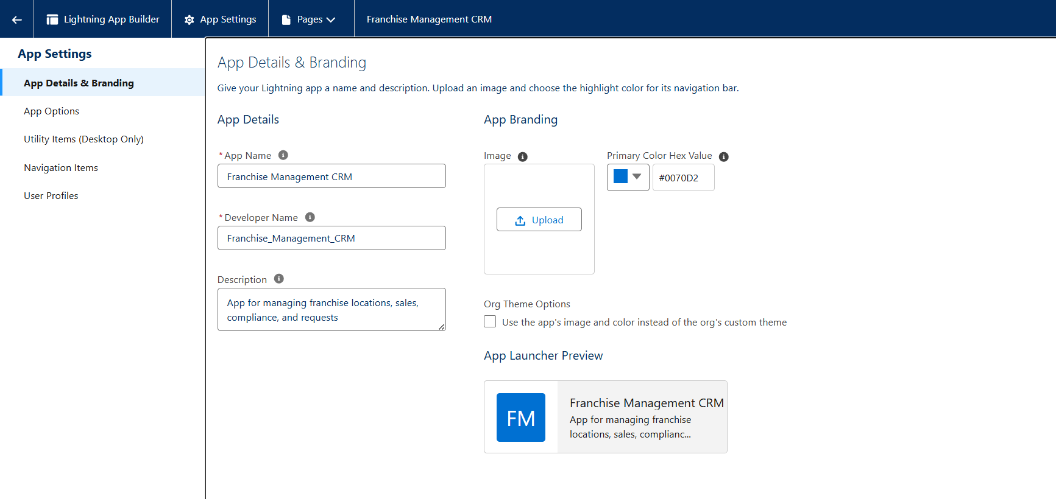

**2. Record Pages**

**Use Case:**

* Customize page layouts for specific objects to improve data visibility and usability.
* Example: Franchisee record page shows location details, status, assigned manager, and related reports.

**3. Tabs**

**Use Case:**

* Organize standard and custom objects for easy navigation.
* Example: Create tabs for Franchisee, Franchise Report, Onboarding Request, and Compliance Check objects.

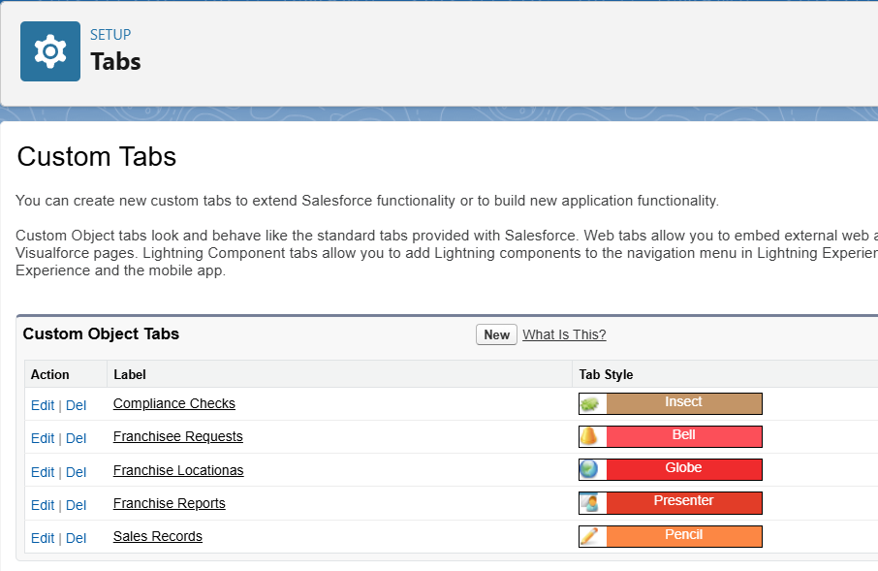

**4. Home Page Layouts**

**Use Case:**

* Design dashboards or components on the home page for quick insights.
* Example: Franchise manager sees total active franchisees, pending approvals, and weekly sales summary.

**5. Utility Bar**

**Use Case:**

* Provide quick access to common tools such as reports, chatter, or custom Lightning components.
* Example: Add utility bar for “Quick Reports” and “Task Manager” to allow managers to check pending actions easily.

**6. Lightning Web Components (LWC)**

**Use Case:**

* Build custom UI components to enhance functionality and interactivity.
* Example: A dynamic dashboard component showing franchise performance by region

**7. Apex with LWC**

**Use Case:**

* Use Apex classes as backend controllers for LWC to fetch, process, and display data dynamically.
* Example: Apex class retrieves all franchise reports submitted in the last month and displays them in a sortable LWC table.

**8. Events in LWC**

**Use Case:**

* Communicate between components using custom events.
* Example: When a franchisee status changes, notify related components to update displayed performance metrics.

**9. Wire Adapters**

**Use Case:**

* Use Salesforce-provided adapters to fetch records reactively.
* Example: Display real-time list of active franchisees or pending onboarding requests without manual refresh.

**10. Imperative Apex Calls**

**Use Case:**

* Trigger server-side logic in response to user actions.
* Example: A “Generate Monthly Report” button that calls Apex to aggregate sales data and update dashboard components.

**11. Navigation Service**

**Use Case:**

* Programmatically navigate users to specific records, tabs, or pages.
* Example: After completing onboarding, redirect franchisee to their dashboard page automatically.

**Phase 7: Integration & External Access**

**Goal:** Enable secure and efficient integration of Salesforce with external systems, APIs, and other platforms, ensuring real-time data exchange and extended functionality.

**1. Named Credentials**

**Use Case:**

* Store authentication details for external systems securely.
* Example: Connect to a third-party supply chain system to fetch inventory updates for franchise locations.

**Sample Setup:**

* Setup → Named Credentials → New
* URL: https://api.supplychain.com
* Authentication: OAuth 2.0 or Username/Password

**2. External Services**

**Use Case:**

* Consume REST APIs declaratively without writing code.
* Example: Use an external payment gateway service to process franchisee payments automatically.

**Sample Steps:**

* Register API via External Services wizard.
* Use Flow or Apex actions to call the external service.

**3. Web Services (REST/SOAP)**

**Use Case:**

* Expose Salesforce data to external systems or consume external APIs.
* Example: A REST API to allow franchisee mobile app to submit daily sales reports.

**4. Callouts**

**Use Case:**

* Send HTTP requests from Salesforce to external systems.
* Example: Notify a third-party analytics platform when a new compliance report is submitted.

**5. Platform Events**

**Use Case:**

* Enable event-driven architecture for real-time updates.
* Example: Publish an event whenever a new onboarding request is approved to notify all relevant systems.

**Sample Platform Event:**

* Event Name: Onboarding_Approved__e
* Fields: FranchiseeId__c, ApprovedBy__c, ApprovalDate__c

**6. Change Data Capture**

**Use Case:**

* Track and notify external systems when Salesforce records change.
* Example: Notify the logistics system whenever a franchise report or inventory record is updated.

**7. Salesforce Connect**

**Use Case:**

* Access external data in real-time without storing it in Salesforce.
* Example: Connect to a cloud-based compliance database for franchise audits.

**8. API Limits**

**Use Case:**

* Monitor API consumption to ensure integration stability.
* Example: Limit daily calls to external payment gateway to avoid exceeding their API limits.

**9. OAuth & Authentication**

**Use Case:**

* Securely authenticate users and external systems using OAuth 2.0.
* Example: Integrate Salesforce with a marketing automation tool where franchisees submit campaign requests.

**Sample Steps:**

* Create a Connected App → Configure OAuth scopes → Use access token for API calls.

**10. Remote Site Settings**

**Use Case:**

* Allow Salesforce to callout to approved external endpoints.
* Example: Enable callouts to https://analytics.example.com.

**Sample Setup:**

* Setup → Remote Site Settings → New → Add endpoint URL

**Phase 8: Data Management & Deployment**

**Goal:** Efficiently manage Salesforce data, ensure data integrity, and deploy changes between environments for smooth CRM operations.

**1. Data Import Wizard**

**Use Case:**

* Import records like Franchisee, Franchise Reports, or Onboarding Requests quickly without coding.
* Example: Bulk upload new franchise locations with relevant details such as name, address, and owner.

**Steps:**

* Setup → Data → Data Import Wizard → Select object → Map fields → Start import

**2. Data Loader**

**Use Case:**

* Bulk insert, update, delete, or export records programmatically.
* Example: Update sales records for all franchises at month-end with a CSV file.

**Sample Steps:**

* Open Data Loader → Choose operation (Insert/Update/Upsert) → Login → Select CSV → Map fields → Execute

**3. Duplicate Rules**

**Use Case:**

* Prevent duplicate franchise or customer records.
* Example: Ensure no two franchise locations have the same name and address.

**Setup:**

* Setup → Duplicate Management → Matching Rules → Duplicate Rules → Activate

**4. Data Export & Backup**

**Use Case:**

* Regularly backup Salesforce data to prevent loss.
* Example: Schedule weekly backup of Franchise Reports, Onboarding Requests, and Franchisee records.

**Setup:**

* Setup → Data → Data Export → Schedule Export → Select objects → Start export

**5. Change Sets**

**Use Case:**

* Deploy metadata changes from Sandbox to Production.
* Example: Deploy custom objects, Apex classes, Flows, and LWC components after testing.

**Steps:**

* Setup → Outbound Change Sets → Add components → Upload → Deploy in Production

**6. Unmanaged vs Managed Packages**

**Use Case:**

* Distribute or deploy pre-built apps.
* Example: Use AppExchange packages for additional analytics or utilities (Managed), or deploy custom components within your org (Unmanaged).

**7. ANT Migration Tool**

**Use Case:**

* Automate deployment using command-line for complex metadata deployments.
* Example: Deploy multiple objects, Apex classes, and triggers from version control.

**Sample Steps:**

* Set up build.xml → Specify source and target org → Run ANT deploy

**8. VS Code & SFDX**

**Use Case:**

* Develop, test, and deploy Salesforce components efficiently using VS Code and Salesforce CLI (SFDX).
* Example: Retrieve metadata from Sandbox, make changes, and deploy to Production.

**Phase 9: Reporting, Dashboards & Security Review**

**Goal:** Provide insights into franchise operations through reports and dashboards, while ensuring secure and controlled access to data.

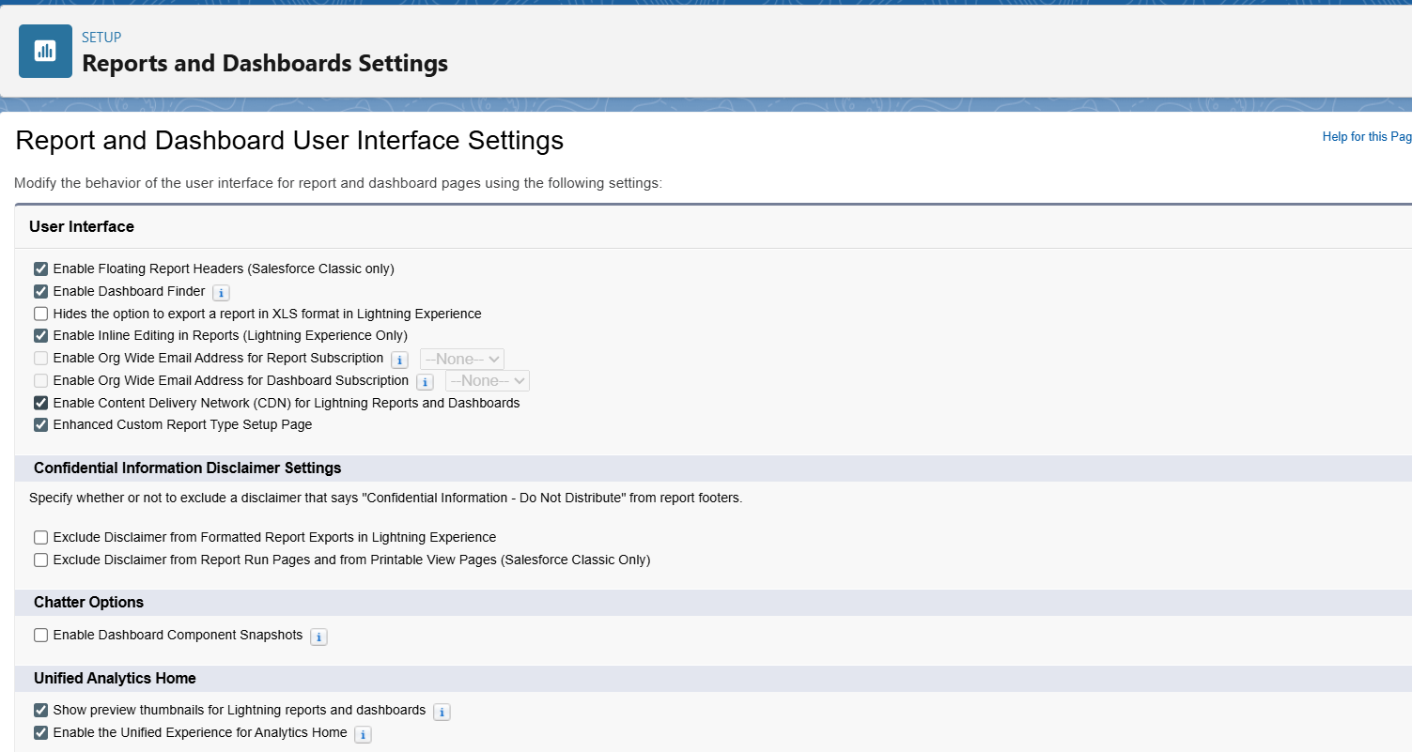

**1. Reports (Tabular, Summary, Matrix, Joined)**

**Use Case:**

* Analyze franchise performance, sales, and compliance efficiently.
* Examples:
  + **Tabular Report:** List all active franchises with contact info.
  + **Summary Report:** Monthly sales totals per region.
  + **Matrix Report:** Compare compliance scores across regions and franchise types.
  + **Joined Report:** Combine sales data and compliance reports for performance analysis.

**2. Report Types**

**Use Case:**

* Define custom report structures based on Salesforce objects.
* Example: Create a report type for Franchisee + Franchise Reports to track performance and issues.

**3. Dashboards**

**Use Case:**

* Visualize key metrics for quick decision-making.
* Example: Franchise Manager Dashboard showing:
  + Total active franchises
  + Pending onboarding approvals
  + Monthly sales per region
  + Compliance pass/fail percentage

**4. Dynamic Dashboards**

**Use Case:**

* Allow users to view data according to their access level without creating multiple dashboards.
* Example: Each manager sees only the franchisees they oversee.

**5. Profiles**

**Use Case:**

* Define user access to objects, fields, and records.
* Example:
  + **Franchisee Profile:** Read/write access to own reports, view dashboard.
  + **Manager Profile:** Full access to franchisees under their region.
  + **Support/Admin Profile:** Configure CRM, manage users, and run deployments.

**6. Roles**

**Use Case:**

* Control record visibility through role hierarchy.
* Example: Manager at top role sees all franchisees below; franchisee sees only own records.

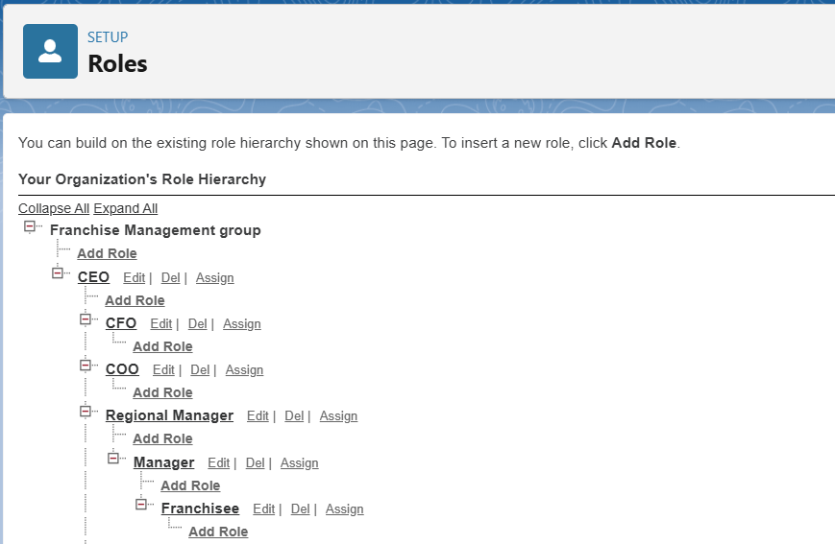

**7. Users**

**Use Case:**

* Manage user accounts, assign profiles, and maintain login access.
* Example: Create users for new franchisee staff with appropriate profiles and roles.

**8. Permission Sets**

**Use Case:**

* Grant additional access without changing profiles.
* Example: Give a franchisee temporary access to a report or dashboard using a permission set.

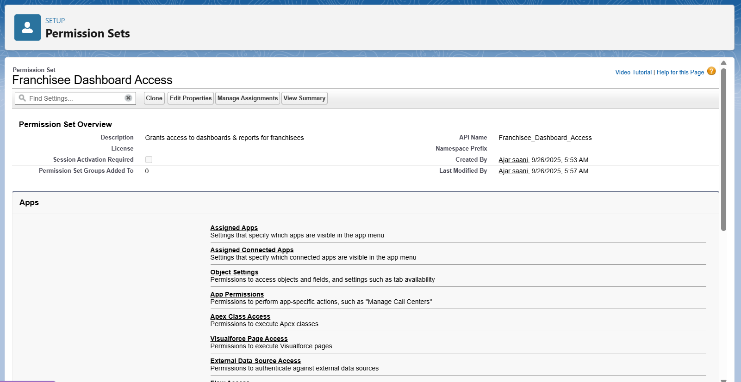

**9. Organization-Wide Defaults (OWD)**

**Use Case:**

* Set baseline record visibility for objects.
* Example:
  + Franchise Reports → Private (only owner & manager can view)
  + Franchise Location → Public Read Only

**10. Sharing Rules**

**Use Case:**

* Provide exceptions to OWD for collaboration.
* Example: Share regional franchise reports with all managers in that region.

**11. Field-Level Security**

**Use Case:**

* Restrict access to sensitive fields.
* Example: Hide salary or commission fields from franchisee profile, visible only to managers.

**12. Session Settings & Login IP Ranges**

**Use Case:**

* Control login times, locations, and session security.
* Example: Restrict franchisees to login only from company network between 9am–6pm.

**13. Audit Trail**

**Use Case:**

* Track changes made by users for compliance and troubleshooting.
* Example: Monitor updates to Franchisee or Report records to identify unauthorized changes.

**Phase 10: Quality Assurance Testing**

**Goal:** Ensure that all Salesforce features, automations, and integrations in the Franchise Management CRM work as expected, and that data integrity, security, and business logic are maintained.

**Testing Approach**

* **Manual Testing:** Verify all flows, approvals, and automations by creating test records and observing expected outcomes.
* **Automated Testing:** Run Apex test classes to ensure triggers, classes, batch jobs, and asynchronous processes are functioning correctly.
* **End-to-End Scenarios:** Test business processes from franchisee onboarding to report submission and approvals.

**Test Case Format**

| **Use Case / Scenario** | **Test Steps (Input)** | **Expected Result** | **Actual Result (Screenshot)** |
| --- | --- | --- | --- |
| Example: Franchisee Onboarding Approval | 1. Create new Franchisee record2. Submit onboarding request | Manager receives approval notification; status changes to "Active" | *(Insert screenshot of approval notification and updated status)* |
| Example: Monthly Sales Calculation | 1. Submit sales reports for franchisee2. Run Batch Apex for performance calculation | Monthly performance score is calculated correctly for franchisee | *(Insert screenshot of updated Monthly Performance Score field)* |
| Example: Validation Rule for Report Submission | 1. Submit report without required fields (Sales Amount) | Error message prevents record save | *(Insert screenshot of error message)* |
| Example: Email Alert for Compliance Report | 1. Create a compliance report flagged as overdue | Email sent to manager | *(Insert screenshot of email received)* |
| Example: Flow for Record-Triggered Update | 1. Update Onboarding Request status to Approved | Franchisee status changes to "Active" automatically | *(Insert screenshot of updated Franchisee record)* |
| Example: Apex Trigger for Task Creation | 1. Insert new Franchisee record | Task for onboarding documents created automatically | *(Insert screenshot of created task)* |

**Key Areas to Test**

1. **Objects and Records**
   * Create, update, delete, and view records in Franchisee, Franchise Report, Onboarding Request, and related objects.
   * Verify relationships, roll-up summaries, and field-level security.
2. **Validation Rules**
   * Test required fields, field formats, and conditional validations.
3. **Process Automation**
   * Test workflows, approval processes, flows, and field updates.
   * Verify that email alerts, tasks, and notifications trigger correctly.
4. **Apex Code**
   * Run all Apex test classes.
   * Check triggers, batch jobs, future methods, and queueable jobs.
   * Confirm code coverage meets Salesforce requirements (>75%).
5. **User Interface**
   * Verify record pages, dashboards, tabs, and LWCs display correct data.
   * Test navigation service, wire adapters, and imperative Apex calls in UI components.
6. **Integration & External Access**
   * Test Named Credentials, callouts, REST/SOAP services, Platform Events, and Salesforce Connect.
   * Verify authentication, API limits, and remote site access.
7. **Reporting & Dashboards**
   * Validate that reports show correct data.
   * Test dynamic dashboards for role-based visibility.
8. **Security**
   * Test profiles, roles, permission sets, OWD, sharing rules, and field-level security.
   * Confirm session settings, login IP ranges, and audit trails work as expected.

Here’s a polished **Conclusion** section for your Franchise Management CRM project documentation:

**Conclusion:**

The **Franchise Management CRM Project** successfully demonstrates the implementation of a comprehensive Salesforce solution tailored to streamline franchise operations. Through this project, key business processes such as franchisee onboarding, sales tracking, compliance monitoring, and reporting were fully automated and centralized.

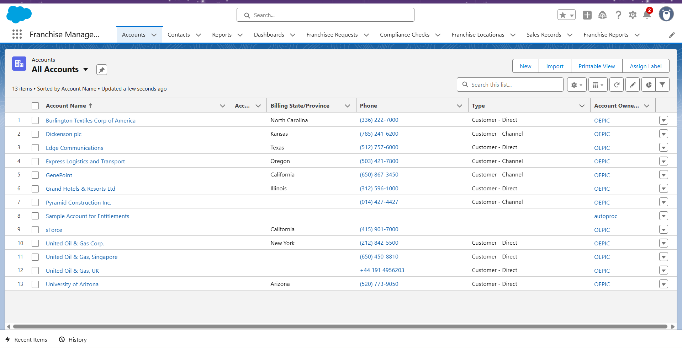

**Key Achievements:**

* **End-to-End Process Automation:** Implemented validation rules, workflows, process builders, approval processes, and Flows to ensure accuracy, compliance, and efficiency.
* **Robust Data Model:** Designed custom and standard objects, relationships, record types, and layouts to manage franchise data effectively.
* **User Interface Development:** Created intuitive Lightning pages, tabs, dashboards, and LWCs to provide a seamless experience for franchisees, managers, and support staff.
* **Integration & External Access:** Configured Named Credentials, REST/SOAP services, Platform Events, and Salesforce Connect to enable secure and real-time data exchange with external systems.
* **Security & Access Control:** Established profiles, roles, permission sets, OWD, sharing rules, and field-level security to safeguard sensitive information.
* **Reporting & Analytics:** Developed dynamic dashboards and custom reports to provide actionable insights on franchise performance, sales, and compliance.
* **Quality Assurance:** Conducted rigorous testing for objects, automations, Apex code, integrations, and user interfaces to ensure reliable functionality.

**Outcome:**  
The CRM solution provides franchise managers with a **centralized, efficient, and secure platform** to monitor franchise operations, track performance, and make data-driven decisions. It also empowers franchisees with clear guidance, notifications, and tools to manage their operations effectively.

**Future-Ready:**  
The system is designed to be **scalable and adaptable**, allowing for future enhancements such as AI-powered analytics, chatbot integration for franchisee support, and mobile app extensions for on-the-go management.